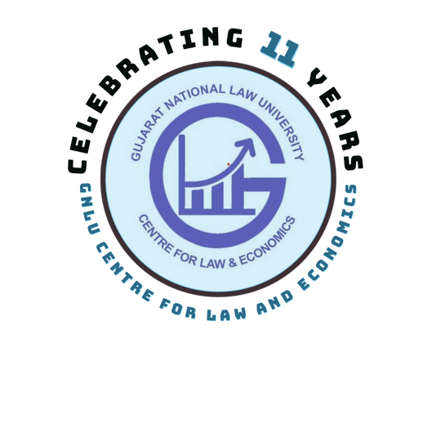GNLU Blog for Law and Economics

GNLU Journal for Law and Economics

4th GNLU Workshop on Economic Analysis of Crime and Constitutional Law

Organized by
GNLU Centre for Law and Economics
2 August, 2023 &
8-10 August, 2023

ABOUT GNLU
GNLU is a statutory University established by the Government of Gujarat through Gujarat National Law University Act, 2003. GNLU is recognised by the Bar Council of India (BCI) and the University Grants Commission (UGC). GNLU is a member of the Association of Indian Universities (AIU); the United Nations Academic Impact (UNAI); and, the International Association of Law Schools (IALS). GNLU offers interdisciplinary legal courses in five faculties namely, BA LLB, BCOM LLB, BSC LLB, BSW LLB, BBA LLB; one post-graduate programme namely, LLM as well as doctoral programmes in law and interdisciplinary fields. GNLU also offers PhD in Economics. This course is offered with an interdisciplinary study of law.

CENTRE FOR LAW & ECONOMICS
The Centre for Law & Economics (CLE) is a centre of excellence for research and training in the discipline of Law & Economics (also referred to as the Economic Analysis of Law). The Centre values rigorous work in the discipline and aims to promote awareness of and research in the field. It carries out courses and conferences for scholars, practitioners and students apart from publications on the economic analysis of contemporary legal issues. It aims to produce quality prescriptions for legislators, regulators and government departments and provide clear explanations and guidance to businesses and ordinary citizens alike.

International Expert
Professor Garoupa received his PhD in Economics from the University of York (UK), also holds an LLM from the University of London (UK). He is the Faculty Editor - GNLU Journal for Law and Economics. He has a long established research interest in the economics of law and legal institutions, empirical legal studies, and comparative judicial politics. He has served as Member of the Executive Board of the American Society for Comparative Law (2021-2023), President of the Spanish Association of Law and Economics (2017-2021), Vice- President of the European Association of Law and Economics (2004-2007), Member of the Boards of the International Society for New Institutional Economics (2006-2009) and of

Professor Nuno Garoupa
Associate Dean for Research and Faculty Development; Professor of Law; Faculty Director of Graduate Studies
the Latin America and Caribbean Law and Economics Association (2009-2011), and as co-editor of the Review of Law and Economics (2004-2010), International Review of Law and Economics (2012-2020), and the Cambridge Elements in Law, Economics and Politics (2020-2021). He has been awarded the Spanish Julián Marías Research Prize (2010).

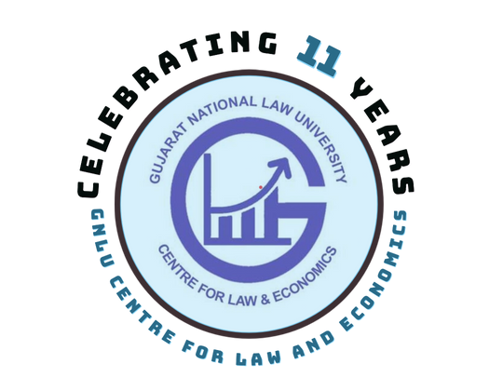

Click here to visit GNLU Journal and Blog for Law and Economics.

4th GNLU Workshop on Economic Analysis of Crime and Constitutional Law

ABOUT THE WORKSHOP:
Economics lets one examine the choices made, given the various constraints they have. As the constraints change, behavior changes as well. Be it Legislature, Executive or Judiciary, any decision making body as well gives considerable attention towards impact analysis through economic tools. It becomes pertinent to read Law and Economics, wherein economic tools are used to better understand the law and to find its efficiency and working. It permits the greater use of economics to examine the law in addition to recognizing the importance of law to an analysis of the economy. Keeping the objective in mind, the workshop will aim at providing an insight to learners regarding application of economic approach in legal arena by touching upon key areas of law i.e., Constitutional law and Criminal Law.

AIM
The purpose of this workshop will be to provide participants with an understanding of two key arenas of legal field using the tools of economic analysis. It will only help them explore the legal areas through an outlook focusing upon the greatest good to respective stakeholders. It will also help them to identify limitations and functions and solutions to improve the quality of respective legal fields.

DURATION
The workshop comprises of 4 days on online medium using Cisco WebEx meetings platform starting from 2nd, 2023 and continuing from 8th to 10th August, 2023. The registered participants will be provided with the meeting link and other necessary details. The workshop will comprise of 4 sessions of two and a half hours each and will begin from 6pm to 8.30PM.

POTENTIAL BENEFITS
- Participants will learn tools and techniques used in the study of Law and Economics.
- Participants will get exposure of learning economic analysis of different arenas of legal studies.

Click here to visit GNLU Journal and Blog for Law and Economics.

METHODOLOGY
Online Lectures, case study, data analysis and e-content.

EVALUATION
Reflection Note.

Who may participate?
- Students/Research Scholars pursuing M.A./M.Phil/Ph.D Discipline in Economics
- Research Scholars pursuing Ph.D in the interdisciplinary study of Law and Economics
- Students/Research Scholars pursuing M.A./M.Phil/Ph.D Discipline in Statistics
- Students/Research Scholars pursuing M.A./M.Phil/Ph.D Discipline in Public Policy
- Students/Research Scholars pursuing M.A./M.Phil/Ph.D Discipline in Development Studies
- Students pursuing Five-Year/Three-year LLB Discipline
- Students pursuing One-Year/Two-Year LLM Discipline
-Academicians teaching and researching in the interdisciplinary study of law and economics. - Professionals working in Banking, Finance or Economics field.
This is not an exhaustive list. Students, Researchers, Academicians, Professionals having an avid interest in the interdisciplinary study of Law and Economics are welcome to be part of the Workshop too.

FEE FOR ACADEMY
- GNLU Participants – 1000/- (INR)
- External Participants – 2000/- (INR) Incl. GST.
- Foreign Participants – 50 (USD).
**Foreign Nationals are required to make payment via HDFC Bank and their participation shall be subject to approval by Indian authorities.
***Bank Details (For foreign nationals only)
  - Name of the beneficiary

  - Address of beneficiary
  - Name of the Bank
  - Bank Branch (Full Address)
  - Bank Account Number
  - Beneficiary Bank's SWIFT Code

PAYMENT & REGISTRATION
-GUJARAT NATIONAL LAW UNIVERSITY
-ATTALIKA AVENUE KNOWLEDGE CORRIDOR, KOBA, GANDHINAGAR,GUJARAT, INDIA-382426
-HDFC Bank Ltd.
-G - 2, GROUND FLOOR, SUPER MALL - II, INFOCITY, GANDHINAGAR - 382 009
-4971450000146
-HDFCINBB

- Registrations are limited to 60 participants on a first come first serve basis.
- Last date of Payment and Registration: 21st July, 2023
- Certificate of Participation will be provided on successful completion of the workshop

STEPS TO REGISTER AND MAKE PAYMENT
- Click here to be redirected to payment portal.
- Select '4th GNLU Workshop on Economic Analysis of Crime and Constitutional Law' in 'Event Name'.
- Fill in all the details and make the payment
- Post payment, kindly register yourself by clicking here.
Kindly keep checking GNLU Centre for Law and Economics' website for further updates: Click here for the website link.

Click here to visit GNLU Journal and Blog for Law and Economics.

SCHEDULE

2nd August, 2023 (Wednesday)

8th August, 2023 (Tuesday)

9th August, 2023 (Wednesday)

10th August, 2023 (Thursday)

TIMINGS

6PM to 8.30PM

Click here to visit GNLU Journal and Blog for Law and Economics.

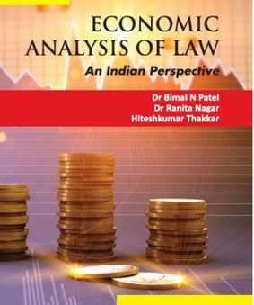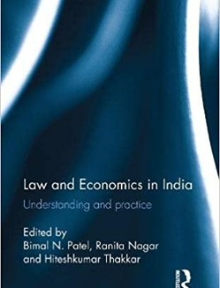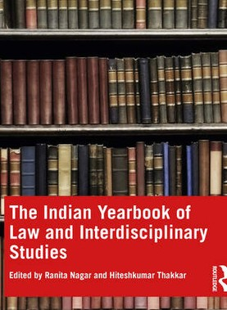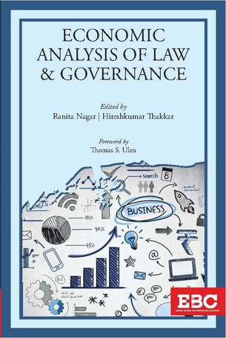

CLE PUBLICATIONS

Click here to visit GNLU Journal and Blog for Law and Economics.

ORGANISING TEAM
CHIEF PATRON

Prof. (Dr.) S. Shanthakumar
Director, Gujarat National Law University

HEAD OF CENTRE CONVENOR

Prof. (Dr.) Ranita Nagar
Professor of Economics
Dr. Hiteshkumar Thakkar
Assistant Professor of Economics

ORGANISING SECRETARIAT
Mr. Ayush Rastogi Teaching and Research Associate (Law)

Krishna Agarwal
Student Convenor
Contact: 9476273728

Saransh Sood
Coordinator Contact: 8219785708
Khyati Maurya
Co-Coordinator Contact: 8004450406
Adya Desai Design Coordinator Contact: 9157516290
Vansh Gaint
Co-Coordinator Contact: 8727995195
Abhimanyu Vyas
Co-Coordinator
Contact: 7433017280

Click here to visit GNLU Journal and Blog for Law and Economics.
CONTACT: glec@gnlu.ac.in

