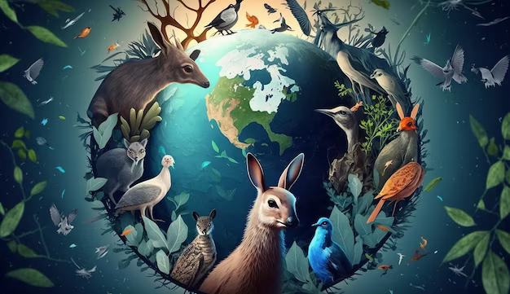

ALC Webinar Week-2023

July 22 - August 27, 2023
Animal Law Centre, NALSAR University, Justice City, Shamirpet, Hyderabad, Telangana- 400 015

Note to Interested Participants

- Please register for the webinar here: https://docs.google.com/forms/d/e/1FAIpQLSdVSK5KDsqx8DWrLCMUopcK-9HgUZhS4DPI8-g5Qk7qqxACIw/viewform?vc=0&c=0&w=1&flr=0
- All participants will be given an e-certificate upon verification of attendance.
- Registration is mandatory for participation and session links will be sent upon registration only to registered participants.

Webinar Week Schedule
July-August 2023

DAY | DATE AND TIME | SESSION NAME
Day 1: SATURDAY | JULY 22, 2023  5pm to 6pm | DOG BITES
Day 2: SATURDAY | JULY 29, 2023  5pm to 6pm | MONKEY HUMAN CONFLICT
Day 3: SATURDAY | AUGUST 5, 2023  5pm to 6pm | CAPTIVE ELEPHANTS
Day 4: SATURDAY | AUGUST 12, 2023  5pm to 6pm | PET SHOPS
Day 5: SATURDAY | AUGUST 19, 2023  5pm to 6pm | DOG MEAT TRADE
Day 6: SATURDAY | AUGUST 26, 2023  5pm to 6pm | FARMED ANIMALS PROTECTION
Day 7: SUNDAY | AUGUST 27, 2023  5pm to 6pm | JALLIKATTU
Concept Note : Session Briefs
Dog Bites
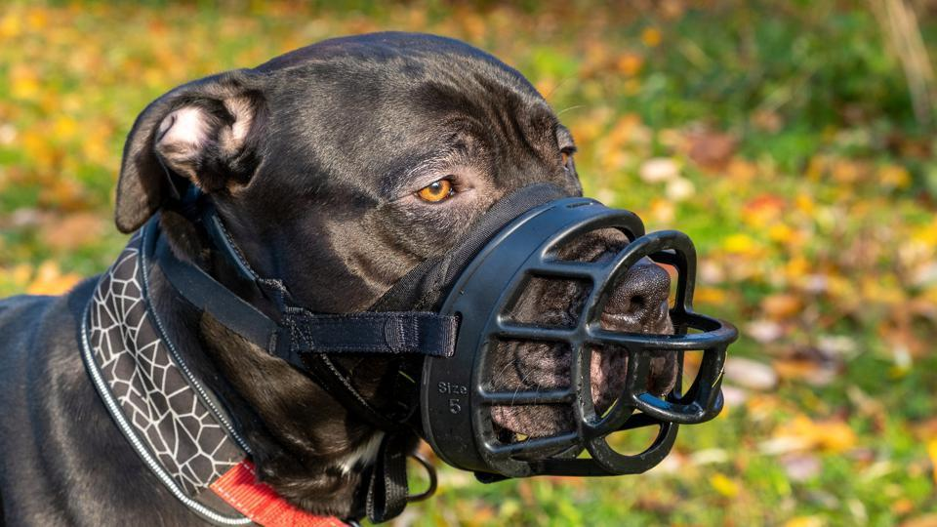
We are honoured to reveal our first speaker for the webinar, Gauri Maulekhi, an animal welfare activist in India. She is the trustee for PFA - People for Animals, India’s largest animal welfare organisation. She has led successful campaigns for animal rights and will be presenting this webinar on Dog Bites.
Dogs are regarded as man’s best friend for their loving nature and loyalty and are one of the most preferred companions as pets. They also have a large presence in public areas as street dogs and form a part of our community. Apart from their loving nature, like every other mammal, dogs too have their defence mechanism. When dogs feel threatened, they may bark loudly, growl and in some cases, they may bite. Every day, across the country, numerous individuals fall victim to dog bites. This can lead to injuries, emotional trauma or sometimes even death, in extreme cases. Cynophobia arises as a result of scary encounters with dogs. If people are aware of the nature of dogs, in many cases, one need not fear dogs. However, the majority of people are unaware of the nature of dogs. Hence, having knowledge of dogs’ nature is an essential survival skill. Therefore, it is a must to develop a strategy to deal with dog bites which include prevention, awareness and education, responsible ownership and efficient response techniques in case of dog aggression or attack. By addressing this issue, this webinar aims to spread awareness and make communities safer thus ensuring the welfare of both people and dogs by proposing how such dog bites can be reduced without causing much harm to both dogs as well as human beings.

Monkey-Human Conflict
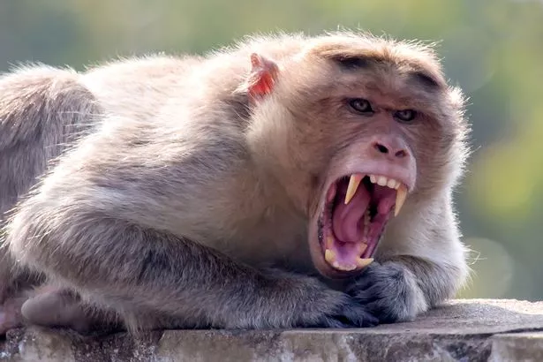
The human population and monkeys, which are both recognised for their adaptability and intellect, are increasingly at odds. Due to extensive urbanisation and deforestation, the monkey threat has gained major attention in many parts of the world. It has resulted in invasion of private property, destruction of crops, financial losses, risk to public safety, or even the spread of diseases. The goal of this webinar is to give a succinct overview of the monkey threat problem and to suggest suitable mitigation measures. This can be accomplished by gaining a thorough grasp of the ecological, economical and societal variables influencing the problem. By putting the techniques into practice, it will be feasible to lessen conflicts between people and monkeys, encourage coexistence, and protect the wellbeing of both species.

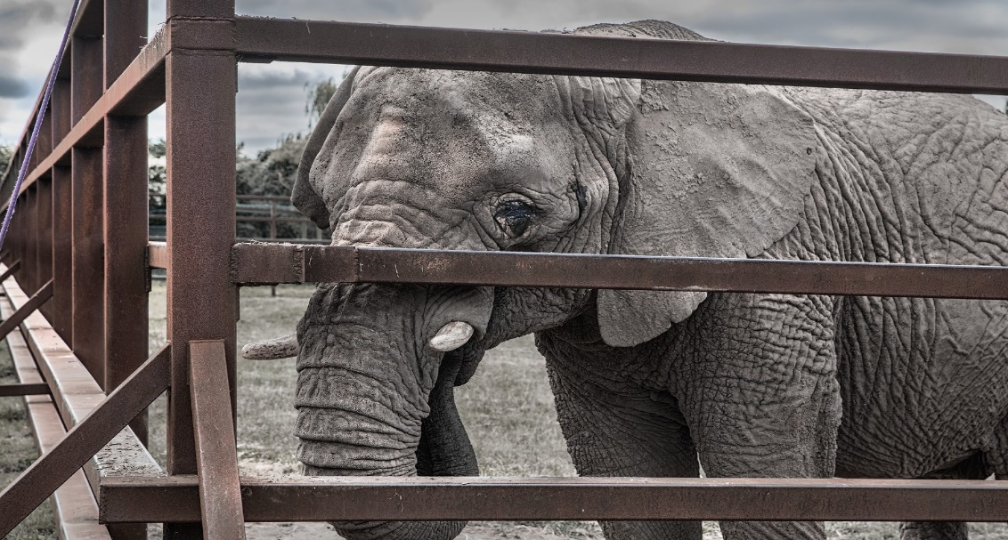
Captive Elephants

Elephant captivity is a sensitive topic that poses issues related to animal care, environmental protection, and cultural customs. Elephants kept in captivity are frequently utilised for logging, amusement, tourism, and religious customs. Inadequate living circumstances results in the physical and mental anguish of several captive elephants. For the administration and care of captive elephants, strong welfare standards and regulations must be established and implemented. It is possible to improve the welfare of captive elephants, lessen their exploitation, and aid in the conservation of this iconic and critically endangered species.

Pet shops

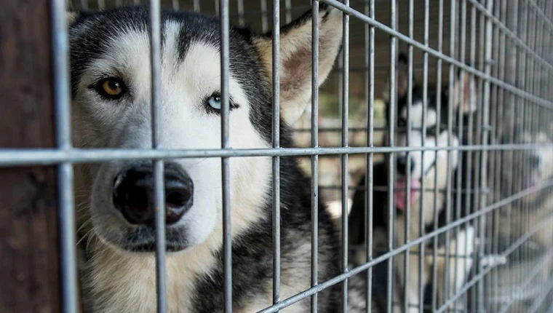

Modernising pet stores is a big step in protecting animals' welfare and encouraging ethical pet ownership. We can create a setting where animals are treated with compassion and given the care that they require. To promote the comfort and wellbeing of the animals, pet stores should provide large enclosures with sufficient airflow and natural lighting. Compliance with defined standards can be ensured by routine inspections and feedback methods. Pet stores should include thorough details about the pet's breed, age, origin and medical history. Display information about safe pet ownership, training and the dedication needed to take care of animals should also be provided. Additionally, we must encourage owners and employees of pet stores to participate in training programs that cover animal behaviour, care and welfare. This forms the basis for today’s webinar.

Dog Meat Trade
Our speaker for this session is Shreya Paropkari, the Farm Animals Campaign Manager at HSI- Human Society International, India. Previously, she used to work as a Cruelty response manager at HSI.
One of the most important things in the consumption of meat is the drawing of lines. Every person must categorise animals that are to be consumed and that are not to be consumed. Some commonly consumed meat across the globe includes Chicken, Mutton, Beef, Pork, Shrimp, Squid, Crabs, Lobsters, and Fish. Beyond this, some people rarely eat rabbits, ducks and other poultry. For most people going beyond the above-mentioned meat is often a question of safety and ethics. People from certain countries consume other types of meat and even insects. Dogs are one of the most abused animals in the world. Consumption of dog meat is observed in some Asia-Pacific countries, mostly. In India, the consumption of dog meat is done both voluntarily and involuntarily. Voluntary consumption of dog meat is very limited and observed in some places in India. Sometimes, it is alleged that some restaurants and meat sellers provide dog meat instead of mutton as they both are red meat and are similar in size. It is obvious that street dogs will be a greater victim of dog meat markets and such stray dogs, in most cases, are not grown in a healthy environment. Hence there is a high chance of dog meat causing severe health conditions. This webinar highlights the problems associated with dog meat and discusses the recent events related to dog meat.

Farmed Animals Protection
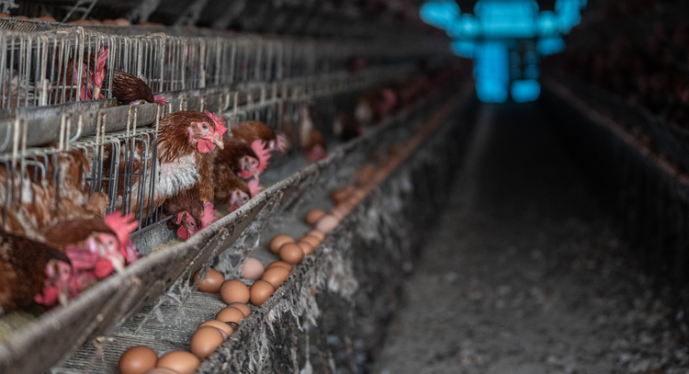
In this session, our esteemed speaker, Alokparna Sengupta, an activist working towards the protection of wildlife and street animals, will be speaking and giving us new insights on the topic Farmed Animals.
Farmed animals are domestic animals that have commercial potential. Farmed animals are raised mostly for meat, eggs and milk. Humans tend to exploit anything with commercial potential, and these farm animals are not an exception. Farm animals are one of the most exploited classes of animals in the world. Money makes humans blind to the extent of not seeing humanity. Most farm animals are raised to be slaughtered, but they are constantly being abused in all stages of their growth and even during slaughter. In most farms, animals are not raised in proper conditions like lack of space, starvation, poor quality of food and water etc. Sometimes, animals are not killed before the skinning and slaughter process. Poultry animals like hens are the most abused animals in the world as a result of their enormous commercial potential. Hens are made to gain more weight for meat purposes, they are starved to make them go into another laying cycle. To extract the maximum amount of milk from a cow, they are artificially inseminated around the year. But the common public often does not see the sufferings of these farm animals compared to the wild animals. This webinar aims to shed light on the sufferings of farm animals and provides suggestions to battle these cruel practices.
In this session, our esteemed speaker, Alokparna Sengupta, an activist working towards the protection of wildlife and street animals, will be speaking and giving us new insights on the topic Farmed Animals.

Jallikattu

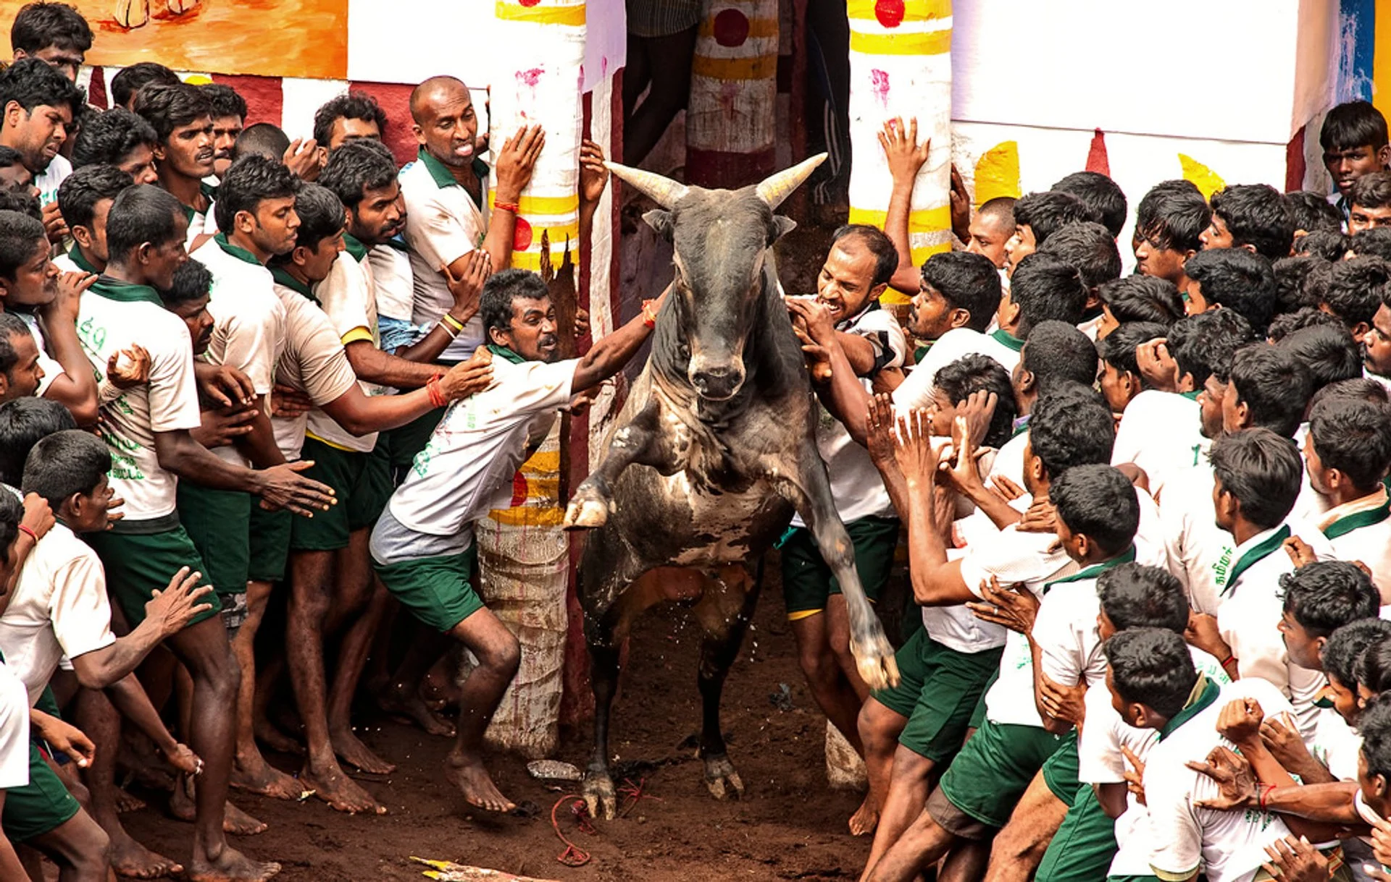

Jallikattu is one of the most controversial traditional sports in India. It is one of the greatest dilemmas between culture and humanity. Jallikattu is a bull- taming sport involving a large number of people, that is played mostly during Mattu Pongal festival. The nature of this sport has the potential to cause harm to both humans as well as the bull. Hence, the legality of this sport is a huge topic of debate. This webinar aims to address the concerns regarding Jallikattu.

