
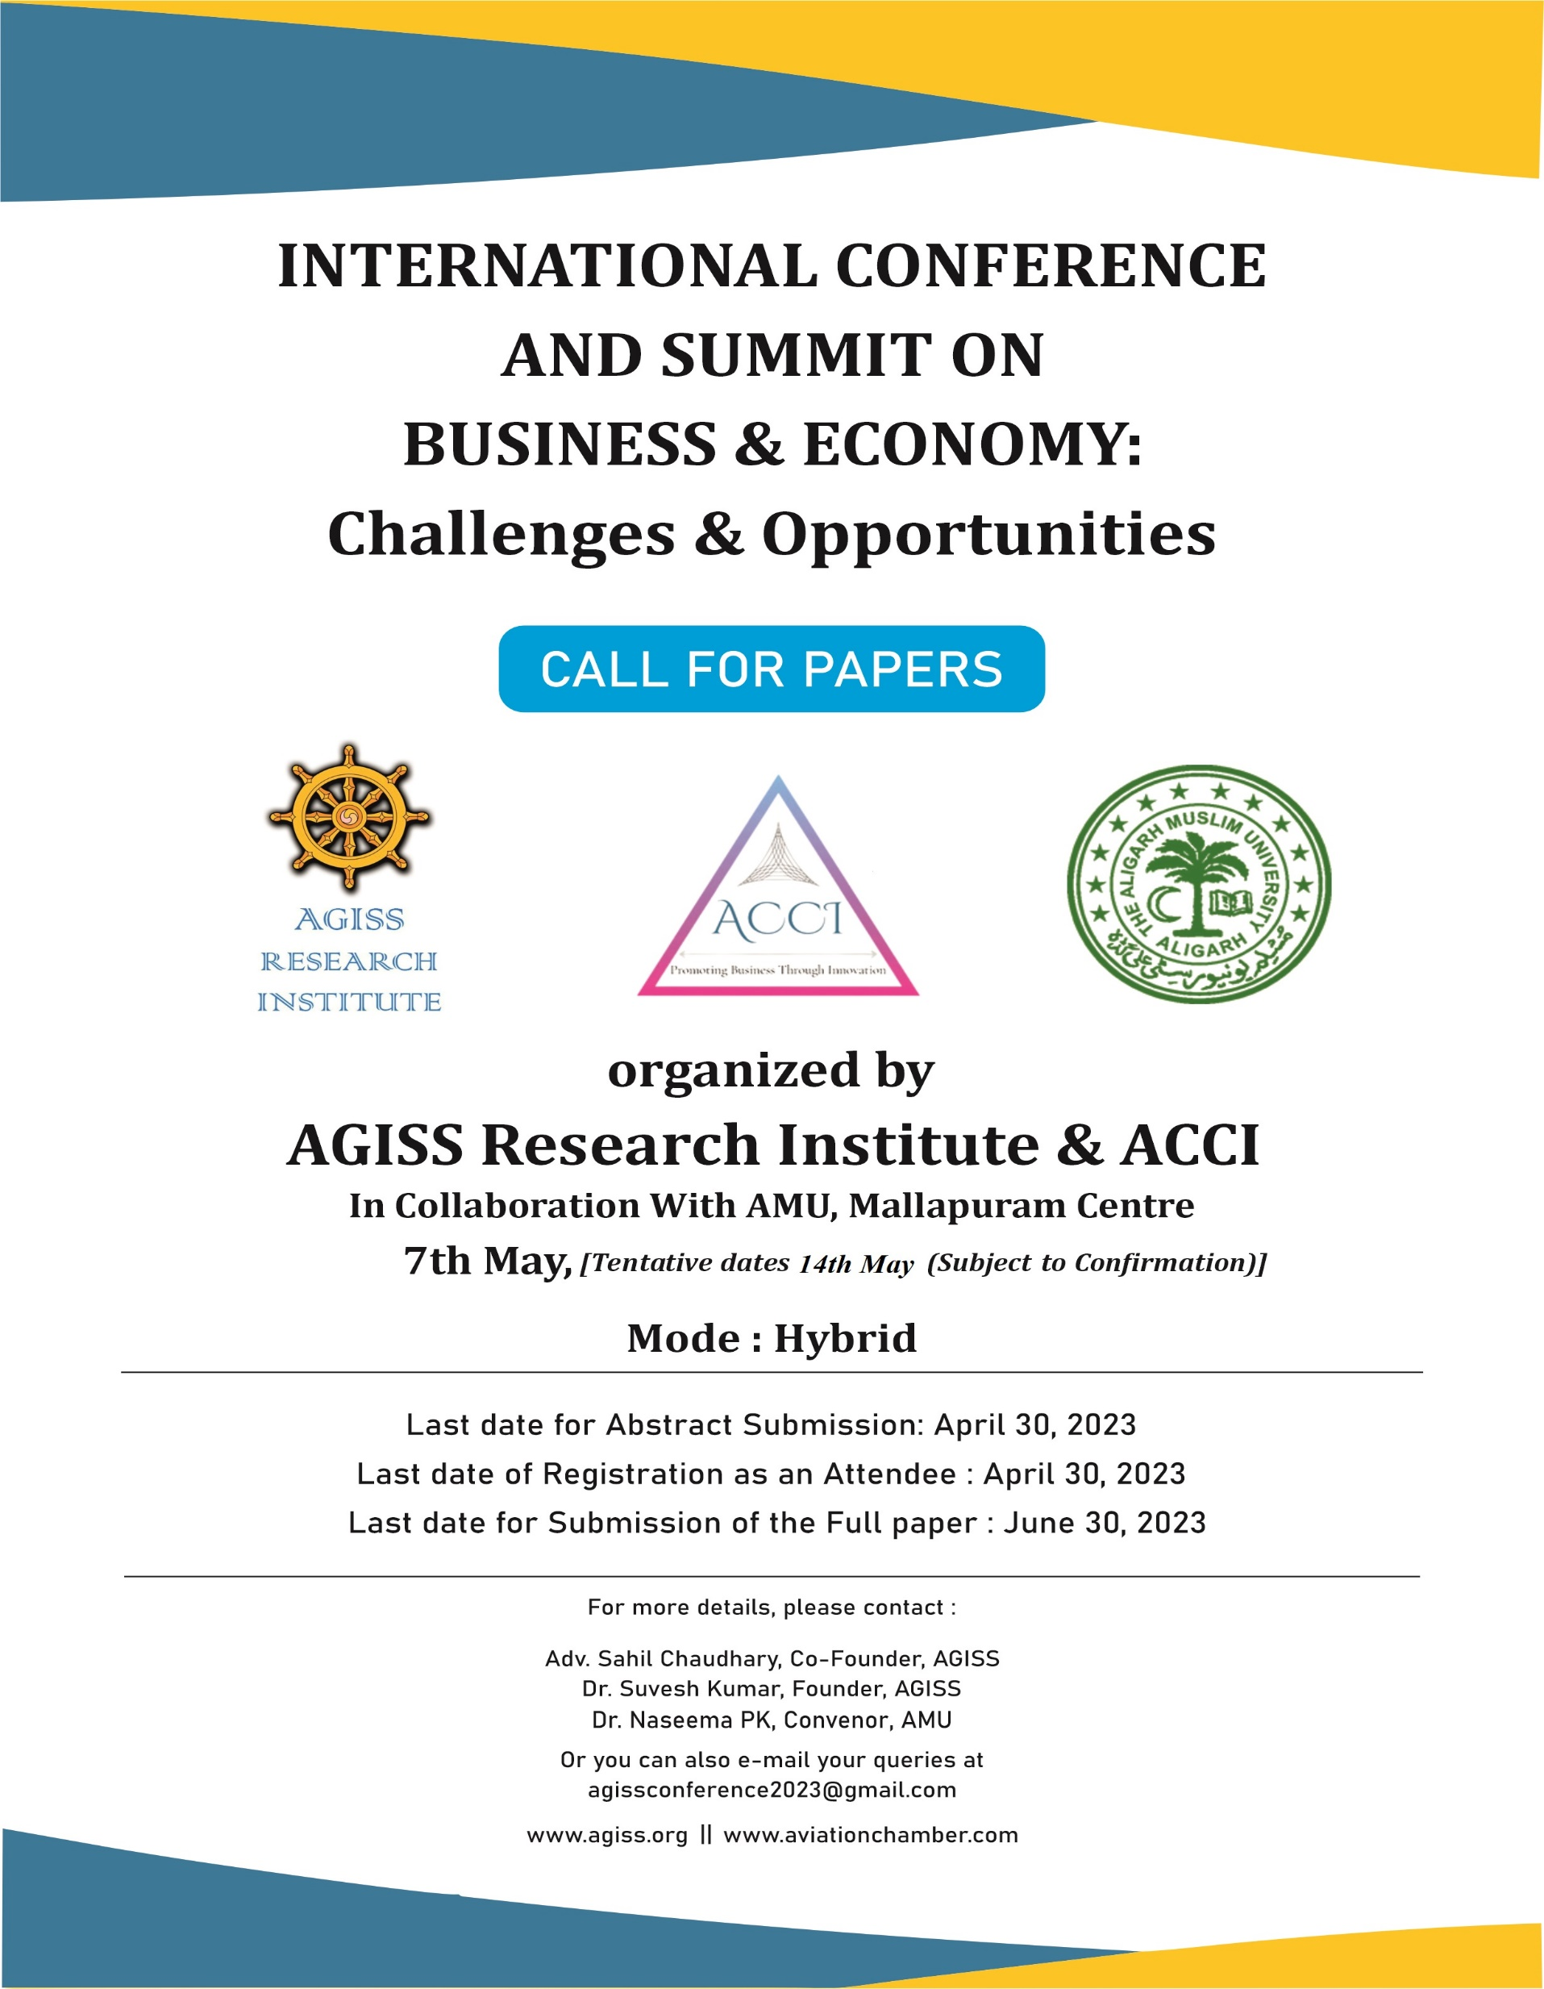




ABOUT THE INTERNATIONAL CONFERENCE & SUMMIT

AGISS Research Institute is organizing an International Conference & Summit on “Business & Economy: Challenges & Opportunities” on 7th May, 2023 [Tentative dates 14th May (subject to Confirmation)] The objective of the Summit is to provide the legal fraternity and academia with a platform where they can present and discuss their research and update society with the new developments and reforms taking place in the field of Business and Economics. The Conference aims to provide law students, researchers, and Ph.D. Scholars, etc. to present their research and help in the development of society. Its main aim is to develop students, researchers, and PhD Scholars, academia etc. with confidence, improve their research, writing and presentation skills. The event will comprise of panel discussions with various experts from the related fields, along with bureaucrats and guests from the Ministry. Simultaneously, there will be sessions of paper presentations where students, professionals etc. can present their papers on their respective topics. These Parallel Sessions will be held in association with various Universities and Colleges through Hybrid Mode.
THEME OF THE INTERNATIONAL CONFERENCE & SUMMIT

Business and Economy : Challenges & Opportunities

ABOUT AGISS RESEARCH INSTITUTE


AGISS Research Institute is an Independent, non-partisan, non-profit public policy organization. Our aim is to conduct high-quality research so that the Governing bodies can make better decisions and to work in conjunction with other Organizations for other important issues pertaining to society.
ABOUT AVIATION CHAMBER OF COMMERCE AND INDUSTRY





AVIATION Chamber of Commerce and Industries aims at promoting business in India and creating a climate where they can operate in a productive & profitable manner. It represents the Business Community of India and works for the promotion & realisation of the Industrial and Commercial potentialities in India.

SUB-THEMES & TOPICS
1) Budget

- New Budget: Prospects & Challenges
- Importance of Niti Ayog and other Public Policy Organizations in Transforming Indian
- Economic Outlook
- Other issues related to the aforementioned sector

2) Corporate Sector: Challenges and Ways to overcome them

- Contemporary challenges in Corporate Sector
- Implementation of corporate laws in era of Globalization
- Rethinking Business strategies & Social Policy
- Income Tax
- GST
- Customs
- Benefits to startups & trusts
- Insolvency & Bankruptcy Code
- Companies Act
- SEBI & Allied Laws
- Competition Act
- Economic Governance
- Investment issues & complexities faced by the public
- Ease of doing Business in India
- Reforms in corporate laws for catapulting India to be 5 Trillion Dollar Economy
- Issues pertaining to E-contracts
- Consumer Laws
- SEZ, EEZ
- Importance of Consumer Commissions, NCLT and NCLAT in speedy adjudication of disputes pertaining to aforementioned laws
- Other issues related to the aforementioned sector

3) Telecom Laws

- Comprehensive Analysis of the recent Bill
- Changing dimensions of Telecom regulations globally

- Contemporary challenges of Telecom industries & recommendations
- Efficacy of telecom law
- Scams in telecom industries & possible solutions

- Scams in telecom industries & possible solutions
- Importance of TDSAT in speedy adjudication of disputes pertaining to aforementioned laws
- Other issues related to the aforementioned sector

4) Environment

- Climate change as a serious issue and Its effect on the Global vis-à-vis Indian Economy
- Environment: Economic growth, Development & Sustainability
- Deep seabed mining
- Analysis of the Kunming-Montreal Agreement 2022: GDP Evaluation, Roadmap to 2030 & 2050
- M.C. Mehta: The Revolutionist
- The concept of Environmental Justice
- Ozone repair
- Nature: The father of natural laws
- Ice age in relation to Global warming
- Bioremediation
- Conservation biology
- The problem of Sea level rise
- Environmental Issues in leather industry
- Sustainable development goals
- Importance of NGT in speedy adjudication of disputes pertaining to aforementioned laws
- Other issues related to the aforementioned sector

5) Agriculture, Labor & Service law

- Impact of new Labour Code
- Issues and challenges in agriculture
- Benefits, to labours & agricultural sector, from the Budget
- Employability & Gig-Economy: Issues & Challenges.
- Digital labor platforms

- 2030 development agenda
- Employment security
- Green jobs
- Labor migration
- Agriculture: Dependency on monsoon/market/cultivation
- Agriculture marketing
- Agriculture: Back loans vis a vis loss of productivity
- Agricultural Trade/Global value change

- Agriculture in India: Industry overview, allied industries, Investment, Government initiatives & the Farm Bill.
- Agricultural policy monitoring & evaluation
- Importance of Agriculture Marketing Board and Directorate of Marketing & Inspection (DMI), Ministry of Agriculture and Farmers Welfare in speedy adjudication of disputes pertaining to aforementioned laws.
- Importance of ESIC, EPFO, ICAR, and other organizations in the development and growth of the aforementioned sectors
- Other issues related to this sector
6) Transport

- Reforms in Railways
- Automotive Sector
- Artificial Intelligence, Tesla Cars (Unmanned)
- Dominance and Dependency over China
- Make in India
- Electric Vehicles
- Fuel economy technology
- Govt. Scrapping guidelines
- Necessity versus Luxury
- Green motor cars
- Challenges in the Aviation sector in 2023 and beyond
- The financial challenges of Shipping companies
- Electric Vehicle: The future of Transportation sector – Efficacy, possible issues & challenges
- Importance and impact of transport on development of Business & Economy
- Hybrid Cars
- Rise in the price of fuel
- Illegal transport of goods and organs; smuggling
- Private and Public transport bodies, roles & challenges
- Transportation related Planning & Policies at Global level
- Importance of Agriculture Marketing Board and Directorate of Marketing & Inspection
- (DMI),Ministry of Agriculture and Farmers Welfare in speedy adjudication of disputes pertaining to aforementioned laws.
- Importance of DG Shipping, Ports Authorities, NHAI, NHIDCL, RTO, DGCA, BCAS, AERA, AAI and other organizations in the development and growth of aforementioned sectors.
- Other issues related to the aforementioned sector



9) IT, Cyber laws & Cyber Security

- Effectiveness of IT Act
- The growing threat of cyber crimes
- Cyber security in the period COVID-19
- Impact on Globalization on the IT Sector
- Nuances of Social-Media
- Impact & Role of social media in the growth of Businesses & influence on Economy
- Right to Privacy
- Efficiency of enforcement agencies throughout the World
- The IT Sector and the Artificial Intelligence: Influence, marketing, challenges & New trends
- Deepfake Technology : Concept, threats, issues, challenges, regulations, impact on economy
- Digital frauds as threat to the economy
- Importance of Cyber Appellate Tribunal, National Informatics Centre (NIC), Unique Identification Authority of India (UIDAI), National Internet Exchange of India(NIXI), Centre for Development of Advanced Computing (C-DAC) and other organizations in the development and growth of aforementioned sectors
- Other issues related to the aforementioned sector.

10)Energy – Renewable & Non-Renewable

- Nuclear Energy
- Energy versus disaster
- Solar power
- Make in India & Renewable Energy
- Impact analysis on the Renewable Energy Sector
- Comprehensive analysis of the All India Economic Strategy 2035 with respect to the Power &
- Energy Sector
- Biomass Energy
- Carbon Tax
- Zero emission
- Impact of Russia-Ukraine war on Russia’s revenue from energy
- Geo-thermal energy
- Russia-Ukraine war leading to a global shift to clean energy
- Renewable Energy versus Sustainable energy
- Importance of APTEL, CERC, SERC, CEA, BEE, NTPC, NHPC, REC, Power Grid and other organizations in the development and growth of aforementioned sectors.
- Other issues related to the aforementioned sector.

11) Education

- New Education Policy: A Path for making India an Educational Leader
- Issues and Challenges in the graduate and post graduate programs
- Fake universities & schools
- Investment by public & private bodies in the Education Sector
- The need, importance & regulation to Sex education
- Mid-day meal Scheme : Impact analysis
- Co-curricular activities
- Education Sector: Analysis, contribution in Economic sector, Investment by private/public bodies
- Education discrimination
- Changing dimensions of Education industry
- E-learning: pro and cons (Implementation, Efficacy, Challenges to the new way of learning)
- Importance of UGC, ICSSR, ICHR, ICPR, AICTE, NBT, NAAC, NBA, NIEPA and other organizations in the development and growth of aforementioned sectors
- Other issues related to the aforementioned sector.

12) Banking & Insurance

- Banking institutions providing support to upcoming ventures and furthering the economic growth
- Financial Institutions and Role of RBI in changing times, with entry of Digital currency
- The role of Insurance in world economy affecting different sectors
- Case analysis on proclaimed offender
- Insurance industry & changing dimensions
- Investment policies and issues
- Importance of RBI, IRDA, Banking Ombudsman, Insurance Ombudsman and other organizations in the development and growth of aforementioned sectors
- Other issues related to the aforementioned sector

13) Sports Sector

- Privileged versus Unprivileged
- Olympic games and sports culture
- Sports Psychology
- Physical Education in schools
- Role of sports in Social Development
- Sports sector: the economic outlook through the Pandemic
- Sports market : Branding & endorsement
- Other issues related to the aforementioned sector

14) Alternative Dispute Resolution (ADR) : An economical way to justice

- Arbitration, Mediation & Conciliation
- Arbitration Act, the latest amendments & their efficacy
- Role of Lok Adalat
- Proposed mediation techniques
- Role of International Commercial Arbitration in adjudicating disputes
- International Commercial Arbitration
- Other issues related to the aforementioned sector

15) Healthcare Industry & Yoga

- Bioethics
- AI in hospitals
- Medical negligence
- Medical industry & biotechnology
- Artificial Organs
- Covid -19
- Scams in hospitals
- Legal responsibility of hospitals
- Superfluous infrastructure and treatment
- Unregistered and ineligible clinics and doctors
- Biopsychosocial perspective of Mental health
- Cancer treatment : Economical aspect
- Meditation
- Awareness to Yoga: Art of living & various forms
- Importance of AIIMS, Indian Nursing Council, Pharmacy Council of India, National Medical Commission (NMC), FSSAI and other organizations in the development and growth of aforementioned sectors.
- Other issues related to the aforementioned sector



16) Hospitality Industry

- Authenticity of Online booking.
- Customer demography and Hotel room price
- Dominance of foreign food outlet (quick service restaurant)
- Growth of startups in the industry and changing tourism landscape.
- Impact of Tourism industry on Indian Economy.
- Other issues related to the aforementioned sector.

17) Public Sector Undertaking

- Performance of PSU’s
- Issues and challenges in the PSUs
- PSU’s role in the upliftment of society
- Major reforms and recommendations relating to PSUs
- Impact of privatization of PSUs on Indian Economy
- Other issues related to the aforementioned sector

18) Social Justice & Gender Justice : Economic aspect

- Women in development of World Economy
- International trends in Women Empowerment
- Feminism
- LGBTQ rights & related laws, Social acceptance
- Relationship between LGBT inclusion & economic development
- Recognition of Same sex marriage
- Glass ceiling across the World
- Women in Non-traditional roles
- Equal opportunity laws & real conditions
- Other issues related to the aforementioned sector

19) Non-Profit Organizations / NGOs

- The problem of financial assistance
- Illegal and illicit activities in the veil of NGO’s
- Role of NGOs/NPOs in socio-economic development
- Other issues related to the aforementioned sector


20 ) Defence Industries

- Make in India (Aatmanirbhar Bharat) in defense industry
- India as a hub for Defense exports to various Nations.
- FDI
- Defence manufacturing in India : Companies & Investment opportunities
- Role of R & D
- Other issues related to the aforementioned sector

21) Media

- Need of specific media law
- Article 19 of the Indian Constitution
- Business-Marketing, Networking & Advertisement
- Media trial & Media verdict
- Other issues related to the aforementioned sector

22) Intellectual Property Rights

- Patent of Covid Vaccines
- Dominance of Pharmaceutical Companies
- TRIPS
- Trademark & Sensory Trademark
- Copyright
- Globalization & Intellectual Property Rights viz-a-viz economic development
- Protection of unregistered literary work
- Biological Diversity
- Geographical Indication
- Impact of IPR in Business & Economy
- Design and its protection
- Space Law And IPR
- Importance of Controller General of Patents, Trademark, Copyright, GI and other organizations in the development and growth of aforementioned sectors.
- Other issues related to the aforementioned sector

23) Governance

- Corporations.
- Police reforms
- Political & Electoral reforms
- International diplomacy
- Political & Electoral reforms
- International diplomacy

- Recent shift in the paradigm of world politics
- Strengthening of Democracy at Grassroot level with Panchayati Raj System and Municipal
- Representation to the unrepresented- 33% Representation to Women in Panchayats.
- Importance of Election Commission and other organizations in the development and growth of aforementioned sectors.
- Other issues related to the aforementioned sector
24) Miscellaneous
- Make in India: A way to strengthen the Indian Economy
- Importance of Chambers of Commerce (FICCI, CII, ASSOCHAM, ICC, PHD Chamber, etc) and
- Business Associations in contributing towards growth of Nation.
- Other issues related to the any sector specifically not covered hereinabove
SUBMISSION AND FORMATTING GUIDELINES
- The submission must be the original work of the authors i.e., shouldn’t be plagiarized and also should be free from grammatical, spelling, and other errors. It must also not contain any defamatory words.
- Kindly do not submit the same paper and abstract to any other journal/book/website etc.
- The author is required to include the declaration form stating that his work is original and hasn’t been published anywhere.
- Submission must be accompanied by an abstract of 300-500 words and author(s) affiliation with a minimum of 5 keywords. No Paper will be accepted without an abstract.
- Author’s Info to be attached:
  - Name of the Author(s)
  - Qualification
  - Name of the Institution/Organization
  - Email Id & Phone Number
- The submission should be made in .doc/.docx/ format only.
- Co-authorship is allowed for up to a maximum of three (3) persons.

- Indian Law Institutes (ILI) rule of footnoting and citation style should strictly be followed in the submissions, non-compliance to this will lead to it being summarily rejected.
- The word limit for research papers is 3000 – 6000 words (maximum, excluding footnotes)
- The body of the paper should be in Times New Roman, with font size 12 and 1.5 line spacing.
- Footnotes should be in Times New Roman, size 1.0 with single-line spacing.
- Page borders should not be used.
- The email should entail the following:
  - Abstract (without the author’s details).
  - Cover Letter [with the name(s), institutional affiliation(s), and contact details of the author(s)]
- Abstracts & research papers should strictly be submitted at Google Form Link only. Notification of the selection of abstracts shall be sent to the participants within two or three days from the date of submission of abstracts.
HOW TO REGISTER & SUBMIT
- To Register as a Presenter & to submit the Abstract: Open the link below.
  - https://forms.gle/qVvMfSjuCXMjbLk67

- To Register as an attendee: Open the link below.
  - https://forms.gle/eyNUijQP45xksQ5M9

REGISTRATION DETAILS
- Paper presentation/Submission/Registration Fees for students/researchers/Professionals/Academicians

- Single Author: Rs 1,200/- INR
- Co-Author (2 or more): Rs. 2,000/- INR

- Foreign Nationals:

- Single Author- $ 30/- (30 US Dollars)
- Co-Author (2 or more): $ 50/- (50 US Dollars)

- Participation/Attending the Panel discussions for students/professionals – Rs 1,200/- (and for Foreign nationals US $ 30/-) per candidate, where the attendees will be a part of the discussion and they will be able to ask their questions to the panel.
- **Please note that in case the co-authorship is a combination of national student/professional and a foreign student/ professional, then the registration fees to be paid will be of co-authorship of the Foreign national.

PAYMENT DETAILS
- Account Holder – AGISS Research Institute
- Account no. – Current Account no. 326621010000045
- Bank Name – Union Bank of India
- Branch Name – Faridabad Greenfield Branch
- IFSC – UBIN0932663

PUBLICATIONS


- AGISS Research Institute shall select remarkable papers presented during the Conference, post the successful conclusion of the review process.
- Subsequently, the selected articles shall be published in a Book on Business, Economics & Corporate Laws to be published by AGISS Research Institute through an International Publisher or Indian Publisher with International Repute.
- Rest of the Articles shall be published in the articles section of the website of our Think Tank.
- Certainty of publication of all papers received either in a book or in the article section of the think tank.


PERKS
Best Presentation (Indian national): Certificate of Merit + Perks
Best Presentation (Foreign national): Certificate of Merit + Perks
Certificate of Participation to all

MODE
- Hybrid mode (Online & Offline)
- Offline Venue: The same shall be conveyed one month prior in advance of the
- happening of event. The Event shall be held in Delhi-NCR Region.

IMPORTANT DATES
- The Last date for Abstract Submission: April 30, 2023 (till 11:59 PM IST)
- Final notification of selected abstracts: within 48 hours of abstract submission
- Last date of Registration as an attendee/participant: April 30, 2023 (till 11:59 PM IST)
- The Last date for Submission of the full paper: June 30, 2023 (till 11:59 PM IST)
- Conference date: 7th May, 2023 [Tentative dates 14th May (Subject to Confirmation)]

CONTACT DETAILS
Adv. Sahil Chaudhary, Co-Founder, AGISS: +91 8377077542
Dr. Suvesh Kumar, Founder, AGISS: +91 8587012770
// +91 92103 03690 //
Vikky Kumar, Student Convener: +91 9483633097
Aditya Bhura, Student Convener: +91 98310 33855
Sanjivani Show, Student Convener: +91 70762 99777
Gunjan Chundawat, Student Convener: +91 94149 25876
Or you can also e-mail your queries at agissconference2023@gmail.com
or Please visit www.agiss.org
www.aviationchamber.com



