2ndALL INDIA MOOT COURT COMPETITION 2020
Vivekananda Law College, Puttur, D.K
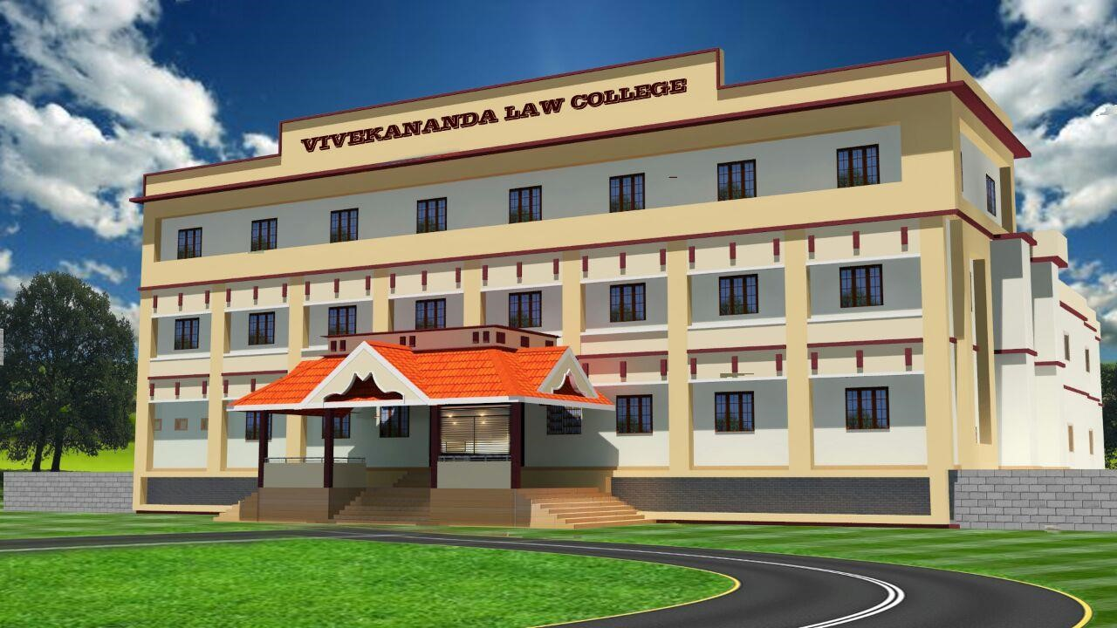

Unit of VivekanandaVidyavardhaka Sangha(R.) Puttur
Affiliated to Karnataka State Law University, Hubballi
Recognised by The Bar Council of India, New Delhi

VIVEKANANDA LAW COLLEGE
NEHARU NAGARA, PUTTUR, DK- 574203.

RULES &REGULATIONS

1. DATE AND VENUE
1.1The Second All India Moot Court Competition will be held at Vivekananda Law College, organized by the Moot Court Society of Vivekananda Law College from 21st February to 23rd February 2020.

2. TEAM COMPOSITION
2.1 The competition will be open to the Law colleges, Law schools and Law Departments recognized by the Bar Council of India. The participation is limited to under graduate students in law, both in the 3-year and 5-year schemes undergoing regular courses.
2.2 The institutions can send a team comprising of three students, which include two speakers and a researcher and their traveling expenses, shall be borne by the respective institutions.

3. REGISTRATION
3.1 The last date for confirmation of participation is 18th January 2020and the Entry is limited to 30 teams (first-come-first basis).
3.2 The Registration forms shall be filled with the photos of team members and signature of the Head of the Institution and a scanned copy of the same should be mailed tovlcmootsociety@gmail.com on or before 18th January 2020.
3.3 Each team shall remit a sum of Four Thousand Five Hundred (Rs. 4500/-) towards registration. The remittance of the same shall be done by DD/ Cheque/NEFT payments.
3.4 Details of the Payments:
- DD drawn in favour of Principal, Vivekananda Law College, Puttur.
- Cheque in the name of “The Principal, Vivekananda Law College, Puttur”.
- NEFT Details:
SB Account Number: 8613101000089
Beneficiary Name : Vivekananda Law College, D.K
IFSC Code : CNRB0008613
Bank : CANARA Bank
Branch : NehruNagar
3.5 The scanned copy of DD/ Cheque/ Screenshot of the NEFT Details along with the soft copy of the registration forms should be sent by email to vlcmootsociety@gmail.com on or before 18th January 2020.
3.6 The hardcopy of the same should be sent by post/ courier to The Principal, Moot
Society, Vivekananda Law College, Puttur, Pin: 574203 and it should reach latest by 21st January 2020.
3.7 The teams shall report at the venue before 09:00AM (sharp) on 21st February 2020.

4. DRESS CODE
4.1 The dress code for the participants during the court sessions shall be as follows:
Female participants:White Salwar Kameez and Black Coat OR White Shirt, Black Pants and Black Coat.
Male participants: White Shirt and Black Pant with Black Coat and Black Tie
4.2 Gowns and Bands are NOT permitted to be worn by the Participants in the Competition.

5. TEAM COMPOSITION
5.1 Each team shall comprise of two speakers, who may be accompanied by one researcher, all of whom shall have to be accordingly designated during the registration process. The names of the speakers and researcher so provided shall not be allowed to be changed subsequently
5.2 Each team will be given a team code and each member shall be given an individual code. The team code shall be sent to the registered teams.
5.3 The team members shall not reveal their identities or that of their institutions in the written submission, supplementary volume or during the oral arguments. Such disclosure shall invite penalties including disqualification.
5.4 Scouting is not allowed. Scouting by the speakers, researcher or any other person affiliated with a team will lead to immediate disqualification of such team. The participants are not supposed to disclose their identity in any manner. The Teams are advised to bring their white paper book, the white paper book should not in any manner disclose the identity.
5.5 If a team scheduled to participate in the oral submissions of a Round does not appear for ten (10) minutes after the scheduled commencement of such Round, the other team shall have to make oral submissions ex-parte.

6. MEMORIALS
6.1 The memorials must be typed in English and must be in Times New Roman font having font size 12 and 1.5 space (this size restriction does not apply to foot notes, which shall be in size 10 and line space ‘single’) with 1 inch margin on all sides printed on one side of A4 size paper. Memorials dealing with jurisdiction, issues involved, summary of arguments, pleadings, conclusion and prayer shall be prepared by each team for both the sides. Issues or pleadings not discussed within the body of the memorial shall neither be included in any other part of the same or be raised before the court.
6.2 The body of the memorial shall not exceed 25 pages and the same would include jurisdiction, questions presented, summary of pleadings, pleadings, conclusion and prayer, annexure, appendices and footnotes. The cover page, table of contents, bibliography, index of authorities, and statement of facts, title page and back cover are not included in these 25 pages.
6.3 The memorials shall not contain any information that will reveal the identity of the participating team and violation of the same if any shall attract penalties including disqualification from the competition.
6.4 The memorial for the Petitioner should be in Blue cover and that of Respondent in White cover. The memorials should be paper bound/ staple bound. Comb/ spiral or any other form of binding will be considered as improper binding. Please avoid plastic front sheets/ separators.
6.5 Cover page of the memorial must state the following
- The cause title
- Identity of the brief as Petitioner or Respondent Second All India Moot Court Competition 2020.
  - The soft copy of the Memorials should be sent to vlcmootsociety@gmail.com on or before 10th February 2020. Four hard copies of the memorials shall be submitted to The Principal, Moot Society, Vivekananda Law College, Puttur at the time of reporting at the venue. Late submission would result in deduction of marks.
  - There should not be any disparity between the soft copy and the hard copy. Any violations would attract penalty. All Hard copies and soft copies of the memorials in the competition shall become the property of the Vivekananda Law College Puttur Moot Society.
  - The memorial Marks will be computed to the score of speakers only in the Preliminary Rounds of the Competition.

7. FORMAT OF THE COMPETITION
7.1 The participants shall only be identified by their respective Code Numbers given at the time of their registration and shall refrain from any act which reveals the identity of themselves or their institutions. The participants shall wear the badge provided by the organizers throughout the days of the competition.
7.2 The format of the competition will be as follows:
Competition Rounds | Basis | Criteria
Two Preliminary rounds | League | Aggregate
Quarter Final | Knock Out
Semi Final | Knock Out
Final
7.3 Fixture of the competition will be decided by the Organizers before commencement of the sessions. The Moot Society reserves the right to make any necessary alterations in respect of the side to be taken by the competing teams in case it becomes absolutely necessary due to withdrawal of any team/teams at the far end or if the competing teams have had no opportunity to argue the other side of the problem. In the matter of disputes or complaints, the decision of the Appeal Committee chaired by the Principal, Vivekananda Law College, Puttur will be final.

7.4 Preliminary Rounds
7.4.1 Each side will have a maximum of 35 minutes to present their case. This would include the time reserved for rebuttal/ sur-rebuttal. The duration of each session will not exceed one hour ten minutes.
The team should allocate equitably the time available to the two individual speakers. There will be TWO preliminary rounds, so that they get an opportunity to argue on both the sides and there will be exchange of memorials for the quarter finals.
7.4.2 Arrangement of Ranking:The teams in the Preliminary Rounds shall be ranked on the basis of below mentioned criteria
- The Overall marks obtained in two Preliminary Rounds shall be cumulated and aggregate shall be listed.
- Top 8Teams shall be selected for the quarterfinals.
- If the tie subsists, the team with the higher speaker score will be allotted the higher rank;
- If further the tie still subsists, the team with the higher memorial score will be allotted higher rank;
- The results of the Preliminary Rounds shall be declared soon after the conclusion of the Preliminary Rounds. The top eight teams will qualify for the Quarterfinals.

7.5 Quarter-Finals:
7.5.1 Each side will have a maximum of 35 minutes to present their case. This would include the time reserved for rebuttal/ sur-rebuttal. The duration of each session will not exceed one hour ten minutes.
7.5.2 The top eight teams from the Preliminary Rounds will qualify for the quarterfinals.
7.5.3 The fixtures shall be decided through the Chronology of results, i.e. (Team ranked 1st v/s Team ranked 8th, Team ranked 2nd v/s Team ranked 7thand so on).
7.5.4 The side for the quarter-finals shall be decided by way of draw of lots.
7.5.5 The quarter-finals shall be a knock-out round.
7.5.6 The win-loss shall be decided on the basis of the aggregate speakers’ score.
7.5.7 No memorial score will be added in the Quarter-final.The win-loss shall be determined on the basis of score so computed.The team with higher aggregate score shall proceed to the Semi- final round.

7.6 Semi-finals
7.6.1 Each side will have a maximum of 45 minutes to present their case. This would include the time reserved for rebuttal/ sub-rebuttal. The duration of the Semi Final Round(s) and Final shall be of One hour 30 minutes which shall include argumentation, rebuttals and sub-rebuttals.
7.6.2 Four teams from the Quarter-Final Round shall qualify for the Semi-Finals
7.6.3 The fixtures shall be decided through the Chronology of results, i.e. (Team ranked 1st v/s Team ranked 4th and Team ranked 2nd v/s Team ranked 3rd).
7.6.4 The side of the team shall be decided by way of the draw of lots.
7.6.5 The semi-final shall be a knock-out round.
7.6.6 The win-loss shall be decided on the basis of the aggregate speakers’ score.
7.6.7 No memorial score will be added in the semi-final. The win-loss shall be determined on the basis of score so computed. The team with higher aggregate score shall proceed to the final round.
7.6.8 The Organizers reserve the right to bring alterations in the duration of the Semi Final and the Final Round. The participants can apportion the time between themselves, but each participant has to argue for a minimum of ten minutesin the preliminary and quarter final rounds and for a minimum of 15 minutesin the semi-final and final rounds.

7.7 Finals:
7.7.1 In the final round, the win-loss shall be decided on the basis of the aggregate speaker score. No memorial score will be added in the finals.
7.7.2 The win-loss shall be determined on the basis of score so computed.

7.8Rebuttal/Sub-Rebuttal: The maximum time provided would include the time that each team may want to reserve for their rebuttal/sub-rebuttal. At the commencement of each session the team shall notify the Court Officer as to the apportioning of time between the 2 speakers (including rebuttal/sub-rebuttal). In case any speaker continues to speak after the completion of his/her time, the additional time that was used, will be deducted from the time allocated to his/her co-speaker, or from the time allocated for the rebuttal/sub-rebuttal, as the case may be. The teams can reserve maximum of 5 minutes for the rebuttal/sub-rebuttal. The final decision as to the time structure and the right to rebuttal/sub-rebuttal shall vest with the Judges.
7.9 The language of the court shall be English. Each team shall be ready with their written briefs and oral arguments for both sides. During the oral rounds, the team shall not be allowed to use any type of electronic devices such as laptops, mobile phones, tablets etc.

8. EVALUATION
8.1 A bench comprising of Three Judges selected from a panel of judges drawn from an array of judicial officers, advocates and academicians will preside over each of the court session. The Final round will be presided over by Three Judges of Higher Courts.
8.2 Each court will assign marks to both individual participant and the team.
8.3 An individual participant will be evaluated to a maximum of 100 marks by each judge. Division of marks will be as follows:
1. | Written Submission (Memorials) (Only for Preliminary rounds) | 20 Marks
2. | Oral Arguments | 80 Marks
8.4 Marks for oral arguments will be awarded on the following criteria.
Sl.  No | PARTICULARS | MAX. MARKS
1. | Substances in arguments, articulation of factual issues, factual analysis and use of evidence | 20 marks
2. | Knowledge of law, interpretation, articulation of legal issues and legal analysis | 15 marks
3. | Use of authorities and citations | 10 marks
4. | Skills of advocacy, persuasiveness and response to questions | 15 marks
5. | Clarity, brevity, ingenuity, language, and style | 10 marks
6. | Court manners and general impression | 10 marks
8.5. The aggregate marks for oral rounds in quarter finals, Semi- finals and Finals shall be out of 100 and apportionment of the same will be informed during the briefing.
8.6. To bring rationalization in the matter of awarding marks and for judicious evaluation, performances are catalogued into Excellent, Good, Average, Below Average and the range of marks to be awarded in each category will be forwarded to the judges.

9. RESEARCHER TEST
9.1 The Researcher’s Test shall be of one hour and objective as well as subjective in nature and shall be general in nature.
9.2 Researcher’s Test is mandatory for all Teams and failure to participate may result in disqualification subject to the discretion of the organizers.
9.3 There shall be an award of negative mark of 0.25 percent for every incorrect answer in the Objective category of questions and negative marking of 1.00 point for each unanswered subjective question.

10. PRIZES AND AWARDS
10.1 Every participant and researcher will be awarded certificate of participation.
10.2 Honours in this competition include
i. Best Team
ii. Second Best Team
iii. Best Female Student Advocate
iv. Best Male Student Advocate
v. Best Memorial
vi. Best Researcher (1st & 2nd)
vii. Best Speaker in Prelims
10.3 Rs. 16,000/- as prize money are slated to be awarded in the competition.
10.4 Rs. 8,000/- will be awarded for runner up
10.5 Other Incentives and Prizes shall be awarded.

- RECEPTION:
  - The travel plans of the teams (A scanned copy by email and hard copy by post) shall be sent to the Convenor, not later than25th January 2020. The teams will be received at Railway/Bus stations from Mangalore/ Puttur. However, the teams will be free to reach on their own and report at the Vivekananda Law College campus at NeharuNagara,Puttur.
  - The nearest Airport at Mangalore which is approximately 55 km from the College. The Puttur Town and Junction Railway Stations are less than 4 km and less than 3 km respectively. The Karnataka State Road Transport Corporation Bus Station is approximately 4 km away from the college.

12. BOARDING AND LODGING
12.1 The boarding and lodging for the teams will be provided from 20thMorning (11:00AM) to the morning of 24th February 2020(11:00AM) ONLY.
12.2 The expenses of additional days shall be borne by the respective teams only.
12.2 Lodging for female and male students will be separate.
12.3 Under NO CIRCUMSTANCES the Moot Society would provide lodging and boarding for any other person other than the three team members.

13. CONTACT
13.1 The participants may feel free to contact us over phone, fax or email. Please refer below for the necessary contact. For quick and timely access please use the mobile numbers.
Sl. No | Name | Mobile | Email
1 | Mrs Akshatha A.P, Principal | 9986910651 | vlcmootsociety@gmail.com
2 | Ms Kumari Shree Raksha, Asst. Prof
3 | Ms Hitha Dechamma, Asst. Prof
4 | Mr Diveen Varma, Student Convenor | 8618005195
5 | Ms Sajini Mohan, Joint Convenor

SCHEDULE OF THE PROGRAMME
Reporting at the Venue | Before 09:00 AM | 21st February 2020
Preliminary Round 01 | 11:30 AM to 01:00 PM
Inauguration | 02:00 PM to 04:00 PM
Researchers Test | 05:00 PM to 06:00 PM
Preliminary Round 02 | 10:00 AM to 12:30 PM | 22nd February 2020
Quarter-Finals | 02:30 PM to 04:00 PM
Cultural Programme | 05:30 PM to 07:00 PM
Semi Finals | 09:30 AM to 12:00 PM | 23rd February 2020
Finals | 01:00 PM to 03:00 PM
Valedictory Function and Prize Distribution | 03:00 PM onwards
DATES TO BE RECKONED
Last date for Provisional Registration | 18th January 2020
Last Date for Soft Copy of Registration forms and DD/ Cheque/NEFT | 18th January 2020
Last Date for submitting the Hard Copy of Registration Forms and DD/ Cheque/ NEFT | 21st January 2020
Submission of Soft copy of Memorials | 10thFebruary 2020
Last Date for sending Travel Plans (Both Soft copy and Hard Copy) | 25th January 2020
Reporting at the venue | 21stFebruary 2020  (Before 09:00 AM)
Sd/-

BEST WISHES

